**Forest Methodist Church**

**July Newsletter**

**Serve Learn Share Praise**

Methodist Church C:\Users\Bryan Guille\Pictures\Church\orb-and-cross-0712.jpg

Bailiwick of Guernsey

**Minister:**

**Rev’d Jacky Cottrell**

**The Manse, 2, Le Chene D’Mont, Le Chene,**

**Forest, GY8 0AL Tel: 234105**

**Email:** [**revdcottrell@gmail.co**](mailto:revdcottrell@gmail.co)

Hello Friends,

I am always, like all of you, amazed at nature, God’s incredible creation. The vast array of colour. Many thanks to those who keep the outside of our church lovely and the flower folk for worship.

## Romans 1:12 ‘Ever since the creation of the world his eternal power and divine nature, invisible though they are, have been understood and seen through the things he has made.’

## I especially marvel at the resilience of plants. Despite my fingers being very ungreen, some things do grow in the manse garden. Some of which I have planted but mostly those wonderful flowers that bees and insects love; some folk may call them weeds because of the position they have decided to flourish in.

## Last year the neighbour was a little unhappy with me for the weeds behind the magnificent array of bushes, were making their way through the fence to his garden. I confess I had never even looked behind there, let alone attend to it. So, I very rapidly went to clear the jungle of mainly ivy, brambles and nettles. Now thinking I would be ahead of the game this year, I did weed earlier. Going behind there again to check on things, I was delighted with the sight of wild strawberries growing in abundance along the bank on which he had his fence erected. Such a blessing, the birds are in for a feast!

## Once the light could reach, the life flourished. We too need the light, the light of Jesus for our lives to flourish. John 8:12 ‘Again Jesus spoke to them, saying, “I am the light of the world. Whoever follows me will never walk in darkness but will have the light of life.”

## Below is a picture again, of nature’s astonishing way. Normally I put celery in the fridge but for some reason, I left it out on top and it really spoke to me of the importance of following the light, the effort we must put in, not just take for granted, if we really really want to flourish!

## Big blessings, Jacky

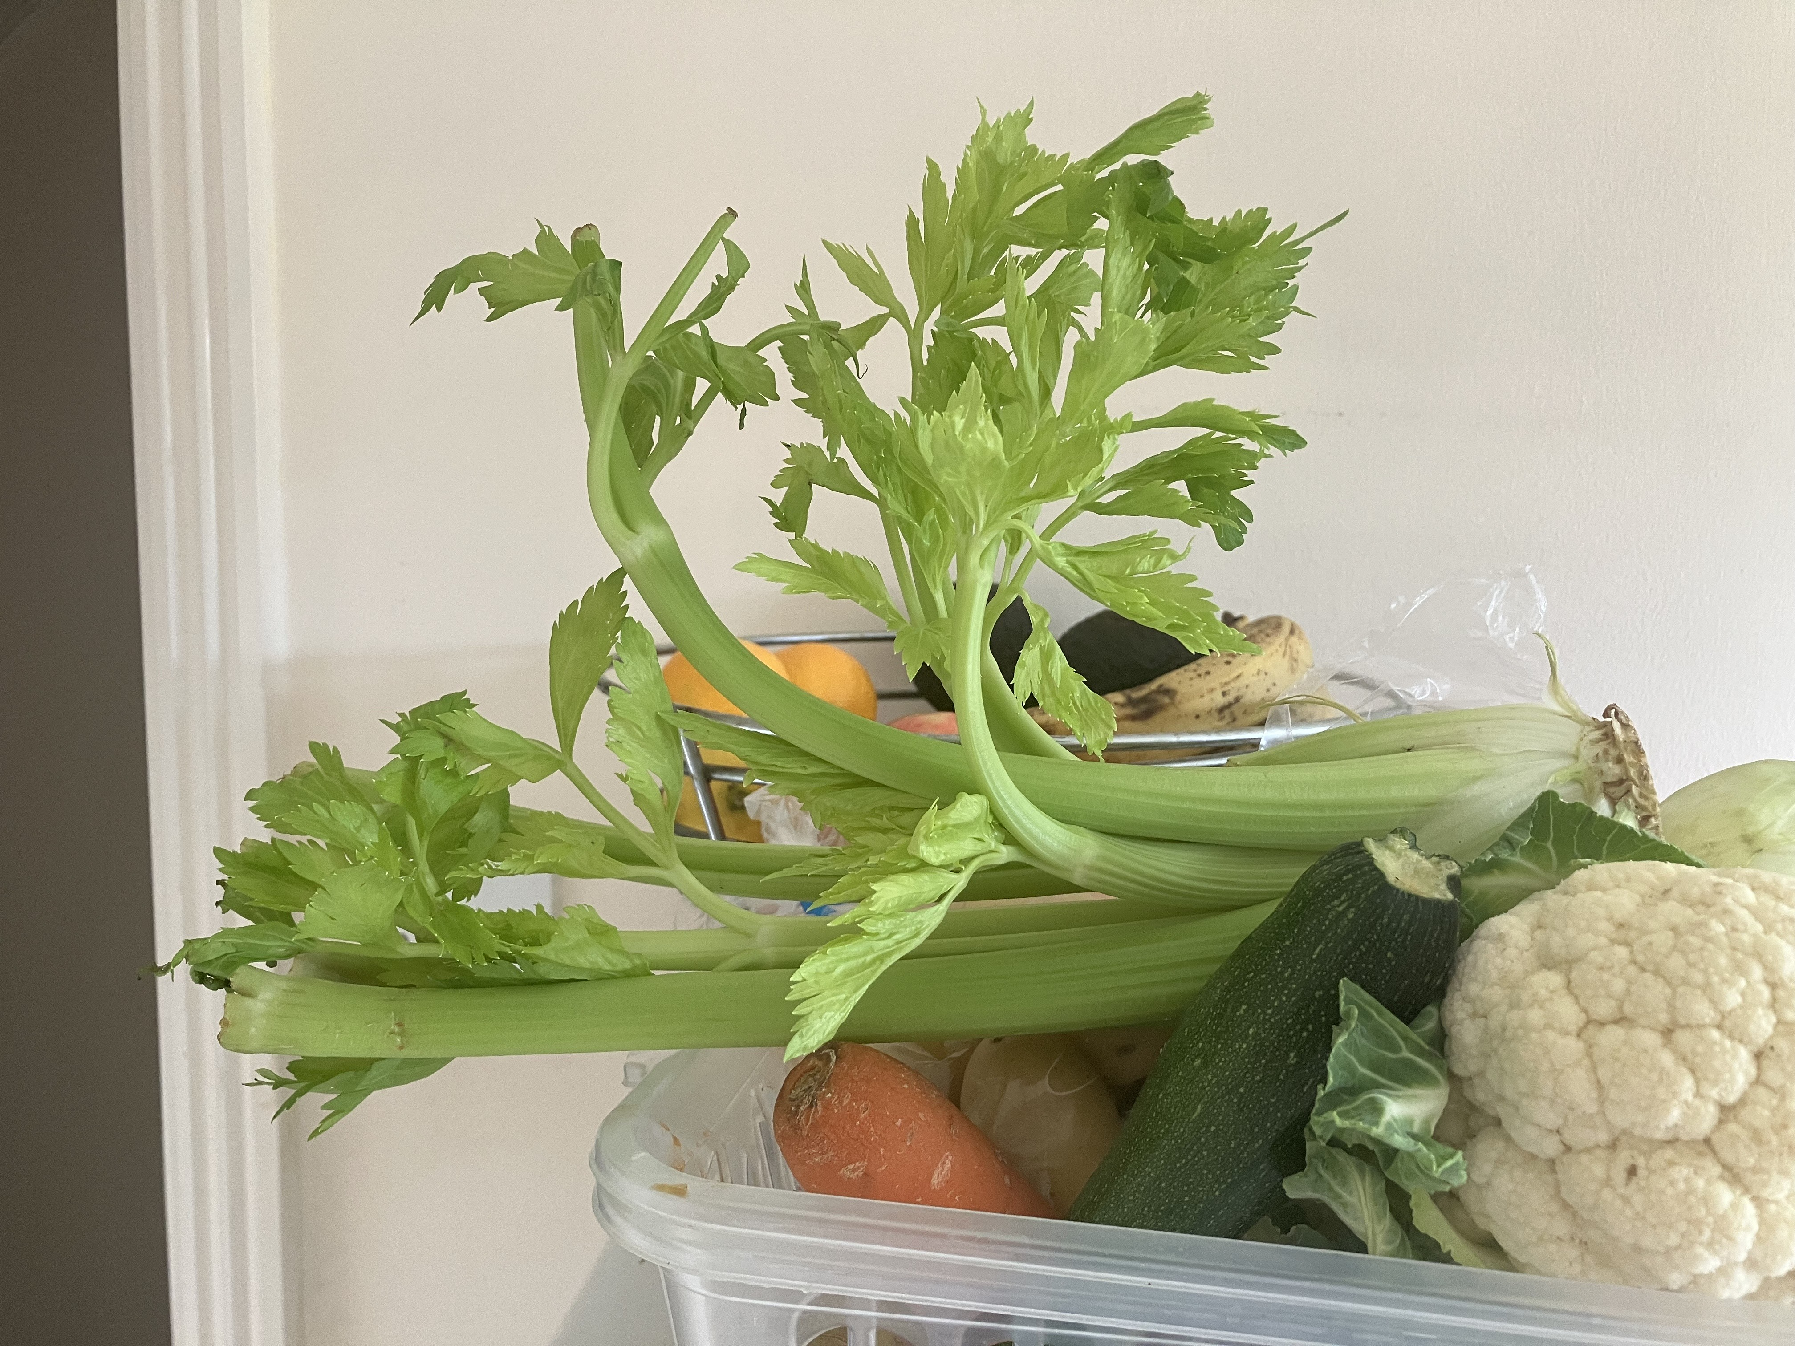

**Indoor/Outdoor BBQ**

**Sunday 17th August**

Service at 11am

Followed by Lunch

Please sign up in the welcome area

Capelles Methodist Church

**12th July at 7.00pm  
     "JOYFUL PIPES”**

Come and be amazed at the range of music  
Peter Le Messurier can play from our organ  
  
Donations to our Church's Homeless projects  
Tumaini/Tanzania & Action for Children/Guernsey

**Annual Church Meeting**  
**27th July** as part of God and Marmalade

Farewell Service to Rev Dallin and Family  
      **27th July 4.00pm** at Les Camps

**MEET & EAT**

This is a house group which meets usually on the first Monday of each month.    We often meet at different participants homes as and when they can offer to host.  There’s usually between 6 and 10 people that come along to enjoy some food followed by a discussion based on the previous Sunday’s G&M but not exclusively.  We meet at 7pm and finish around 9pm.  There is a minimum donation requested of £5 to cover the cost of catering.

**July’s meeting will be at Sarah Plumley’s at 7pm on Monday 7th July**

Should you wish to give us a try you can either put your name(s) on the list in the Welcome Area or call Carole on 07781 438265.

**FOREST LADIES GROUP.**

**10TH July** Breakfast is **POSTPONED**  
     Till **the 14th August at 10.00am**  
  
     **24th July 6.00pm**  
     Picnic and Quiz at Blancheland Park  
     (Please bring your own picnic, drinks provided)  
  
     Warm welcome to all Ladies  
     Any queries contact Beth on 07781 163564

**Christian Aid in 2025**

**This year’s Christian Aid Week focused on Christian Aid’s work in Guatemala, Central America, where the climate crisis is causing the seasons to intensify and shift erratically. As a result, farming communities have to battle devastating floods and intense heatwaves. Water sources are drying up and vital crops are failing, plunging farming families into hunger and poverty.**

**For 80 years, Christian Aid has been fighting poverty and injustice. With your support, we’ve been able to offer hope to communities who need it most. And over these 80 years, we’ve harnessed something formidable. Something that can’t be silenced by injustice. Something that refuses to sit back and watch poverty ravage communities.**



**Prayer**

God of Hope,  
  
We give thanks for 80 years of Christian Aid’s faithful witness, for

lives transformed, communities restored,

and justice pursued.  
  
In a world of challenge, You have stirred hearts to compassion,

lifting the weary, feeding the hungry, and bringing light to the darkness.

Renew our strength to walk in Your love

and labour for Your kingdom.  
  
May hope continue to rise, justice flow like a river,

and peace embrace the earth.  
  
With grateful hearts, we trust in Your faithfulness for the years ahead.

In Jesus' name,

**Amen**

**Preaching & Duty Stewart Schedule**

God & Marmalade is at 8.45am

|  |  |  |
| --- | --- | --- |
| **Date** | **AM Preacher** | **Duty Steward** |
| **6th July** | Fellowship (N. Pascoe) | Nev |
| **13th July** | Jacky Cottrell (HC) | Rosemary |
| **20th July** | Stephen Dallin | Sarah |
| **27th July** | Jacky Cottrell (AGM) | Carole |

Evening Service is at 6pm

|  |  |  |
| --- | --- | --- |
| Date | PM Preacher | Duty Steward |
| **6th July** | Jacky Cottrell | Pam |
| **13th July** | Fellowship | Sarah |
| **20th July** | Jacky Cottrell | Pam |
| **27th July** | @ *Les Camps*  *Farewell to Dallin family* | N/A |

**Flower Rota**

|  |  |
| --- | --- |
| **Date** |  |
| 6th July | Andrea Martin |
| 13th July | Carole Jehan |
| 29th July | Pam Gidney |
| 27th July | Rosemary Willey |

**G & M Breakfast Rota**

|  |  |  |  |
| --- | --- | --- | --- |
| **Date** | **Breakfast** | **Setting Up** | **Cloth Wash** |
| **6th July** | Sandra/Ian Jenny | Leon | Jenny |
| **13th July** | Carole/Nev | Steve/Jan | Margaret |
| **20th July** | Debbie/Rosemary | David | Sarah |
| **27th July** | Sarah | Michelle G | Rosemary |

Welcome Steward Rota

|  |  |  |
| --- | --- | --- |
| **DATE** | **AM** | **PM** |
| **6th July** | Andrea | Beth |
| **13th July** | Sarah K | Brian |
| **20th July** | Brian | Sarah P |
| **27th July** | Sandra | N/A |

**With grateful thanks to all who give their time to the service of the church**

**☼**

Notices/articles for next month let Michelle know by **Wed 24th July**

Tel no: 01481 266019/07781 166019

email: [mgilson_gsy@hotmail.com](mailto:mgilson_gsy@hotmail.com)

By a 17th century nun...Prayer for the month.

Lord,thy knowest better than I know myself,that I am growing older and

will someday be old.

Keep me from getting talkative and particularly from the fatal habit of

thinking I may say something on every subject and on every occasion.

Release me from craving to straighten out everybodys affairs.

Make me thoughtful, but not moody,helpful,but not bossy.

With my vast store of wisdom it seems a pity not to use it all,but Thou

knowest, Lord,that I want a few friends at the end.

Keep my mind free from the recital of endless details;give me wings to get to the point.

Seal my lips from my many aches and pains.They are increasing and my

love of rehearsing them is becoming sweeter as the years go by. I ask for

grace enough to listen to the tales of others pains. Help me to endure

them with patience.

Teach me the glorious lesson that occasionally it is possible that I may be mistaken.

Keep me reasonably sweet.I do not want to be a Saint.

Some of them are hard to live with,but a sour old woman is one of the

crowning works of the devil.

Help me extract all possible fun out of life.

There are so many funny things around us and I do not want to miss any

of them.

Amen

**Dates for your diary**

Sunday 17th August BBQ lunch

Sunday 14th September Harvest Festival

Saturday 25th October Soup and cake on a plate

Guernsey Circuit Alpha

Helen is organising an Alpha course across all our churches. She is encouraging people to come and experience it so that they can inspire new people seeking a faith next time. Banners will be appearing outside our churches to let our communities know. Helen does need volunteers to run this, specific requests will be coming. For now, please hold each Wednesday evening from 1st Oct until 10th Dec if you are interested. This is a big commitment of 11 weeks and Helen will be coming around all our churches to share with us all it entails.

**Romans 5:5** - 'And hope does not disappoint us, because God's love has been poured into our hearts through the Holy Spirit that has been given to us.'

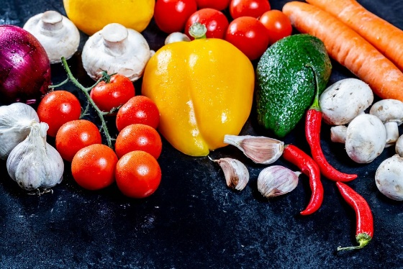**Harvest Festival**

Sunday 14th September

**Theme:**

**‘Home is where the heart is’**



**Tme to get creative**

All things home!

home-made, home grown, home crafted

**Collection boxes**

**Used stamps for charity** **Guernsey Welfare Services**

Collected and sold to raise funds for We collect non-perishable goods to be

The worldwide work of Christian Aid. Passed on to the GWS to support the

If you have any, please leave them in Work of their foodbank. Please leave any

The box in the welcome area. donations in the box in the foyer 



Fairtrade stall at Forest

2nd Sunday of the month

**PARKING FOR THE AIRPORT**

The Forest Methodist Church is inviting members of the Methodist Circuit the use of parking spaces in our car park when they need parking for the airport.

We are letting out five spaces, on a first come, first served basis, at a cost of £20 per week or part thereof. These parking spaces will be at the back of the top rear car park and will be delineated.

THIS WILL BE ENTIRELY AT CAR OWNERS RISK

To reserve a space please email [rosemary.willey@gmail.com](mailto:rosemary.willey@gmail.com) and cc to [carolejehan1972@gmail.com](mailto:carolejehan1972@gmail.com).

You will need to provide your car number, dates required and a contact telephone number. Please can you display your Christian name on your dashboard when leaving the vehicle.

It should be noted that on the rare occasions when the car park is full, I.e. funerals, access to your vehicle may be temporarily delayed.

THERE IS TO BE NO UNAUTHORISED USE OF PARKING SPACES WITHOUT FOLLOWING THE ABOVE GUIDELINES.



**Prayer Pages**

**IN YOUR PRAYERS**  
If you know of someone who would appreciate being on our prayer list, please ensure you have the person's permission before passing their name to Michelle.

Please pray for Ron Gould, Win De La Mare, Karen Harrison,

Rachel Meinke, Caroline Treharne, Joyce Baudains,

Margaret Boden-Heaume, Bob Cartmell,

Rev John Luff and his wife Carole,

Howard Ellis (Sandra’s son), Debbie Hobbs,

Colleen Ogier and Debbie Dorey

**Bailiwick of Guernsey Churches Prayer Cycle for 2025**

Jul 06 Our Lady Star of the Sea Catholic Church, Delancey

Jul 13 Guernsey Airport, Harbour & RNLI (Lifeboat) in Guernsey

***(Sea Sunday)***

Jul 20 St Matthew’s church, Cobo

Jul 27 Salvation Army: Le Picquerel Fortress & Nocq Road shop, cafe & community centre

## FACTOR 7

**Please pray wherever you are: at home, work, in your car or shower, pray for**

7 minutes at 7am and/or 7pm

FOCUS THIS MONTH

Let us remember in prayer those in government, both locally, in the UK and globally. Pray for wisdom where difficult decisions need to be made.

As the school year ends, give thanks to God for all the learning that has taken place, for the dedication of staff, commitment of students, and for good rest and recreation for all over the summer break.



**The Lord’s Prayer**

Children’s versions of the Lord’s Prayer:

* Our Father, who are in heaven, hello! What be thy name?
* Give us the day our daily breath.
* Our Father, who are in heaven, Hollywood be Thy name.
* Give us this day our jelly bread.
* Lead us not into creation.
* Deliver us from weevils.
* Deliver us from eagles.

The best vitamin for a christian is B1.

Don’t give up, Moses was once a basket case.

Preach the Gospel at all times. Use words if necessary.